Patrice Moracchini
CSD310-308A(2261-DD)
Nov 12, 2025

MySQL Install
Module 4.2 Assignment
Pr. Sampson

Initial Database Connection

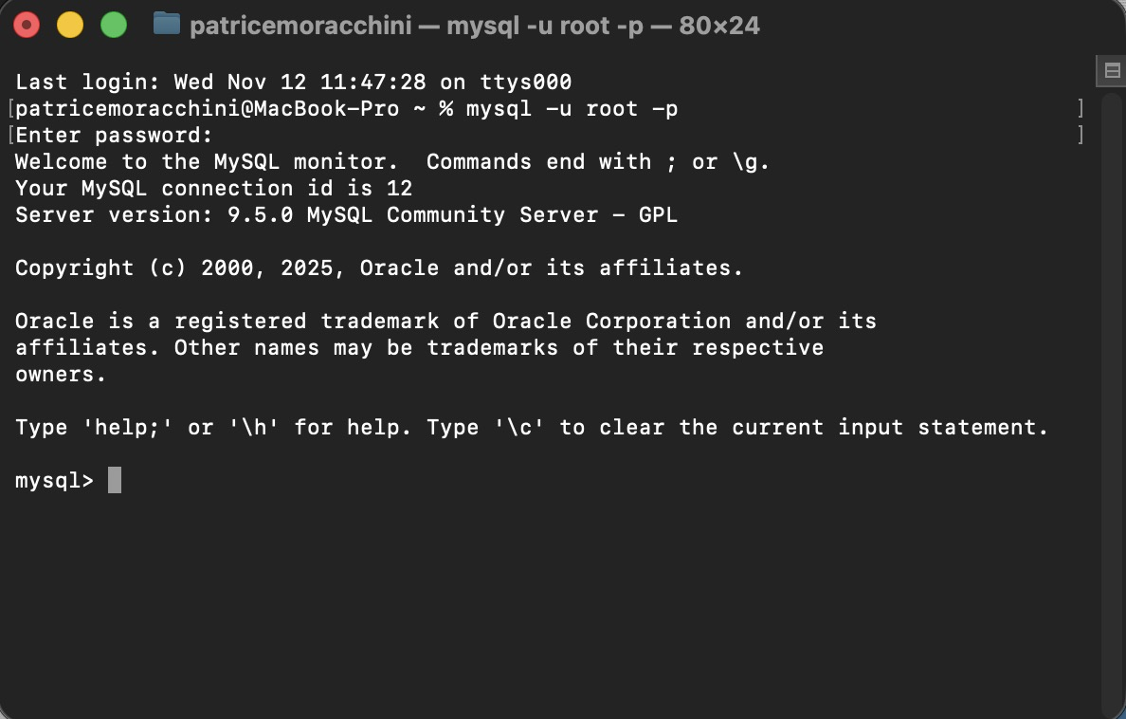

Database Creation

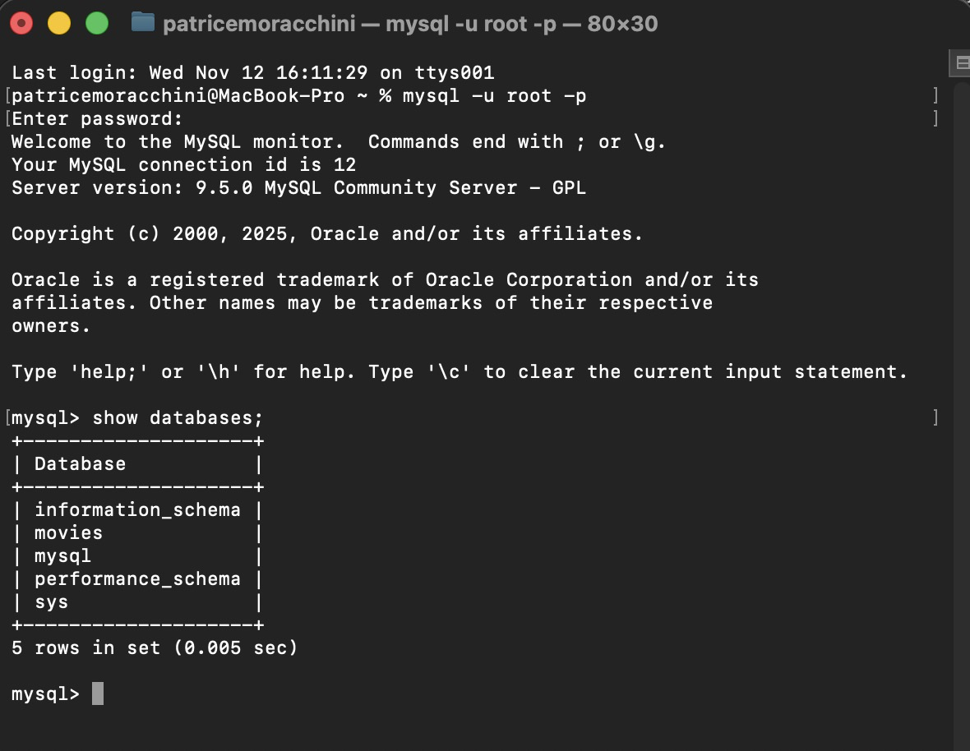
I was able to create the movie database, but I ran into different types of errors that prevented me from doing it for a long time, so I used ChatGPT to troubleshoot the problems.
First, before installing the server, I encountered a problem with the DMG image, and I received an error message indicating that the image was corrupt. Even if it was done downloading, it seemed it wasn’t, and the package couldn’t be expanded.
The Server in the macOS preference settings seemed to be glitchy. Initially, when I initialized the database, the server crashed. At some point, I attempted to shut down the server to reinstall it, but it wouldn’t shut down. It is very frustrating, mainly because I don’t know how to manage those kinds of issues. Yet.
Then I encountered different errors related to the database creation that ChatGPT helped me correct.
This is why there is a delay of several hours between the time I connect to the server and the database creation.

